IST 659 Database Administration and

Database Management Concepts

Project Deliverable: Family Financial Database

Gilbert Guyah

**Table of Content**

1. **Summary …………………………………………………….……. 3**
2. **Database Design Phase ………………………………………….… 3**

**2.1 Constraints ……………………………………………………. 4**

**2.2 Dependencies…………………………………………………… 4**

**2.3 Relationships between tables………………………………… 4**

**2.4 Tables (Entity and Attributes) ……………………………….… 5**

**2.6 Physical Model ………….………………………………………. 6**

1. **Implementation: …………….……………………………………….6**
2. **Pilot (Test and Evaluate) ……………………………………………6**

1. **Finalize Data (Output) …………..………………………………….6**
2. **Glossary of Acronyms ………………………………………………. 7**
3. **Glossary of Terms …………………………………………………... 8**

**Charts / Tables**

**Design Phase Table …………………………………………. 3**

**Conceptual Model Chart ………………………………………. 5**

**Normalized Logical Model Chart ……………………………… 6**

**Summary:**

Management of my finances and accounts has been an actual issue for a long time. Providing my family's financial security is an essential part of the financial planning process. Using non- customizable dashboards or financial statements from our bank was not adequate to track our expenditures. My objective is to create a customizable personal financial database that will allow the management of our family’s incomes and expenses effectively and efficiently.

Using extracts from our bank statements within the last 12 months, I will analyze the data to present an opportunity to improve financial decision marking by revealing saving options, unnecessary fees, and identify trends in spending habits.

**Stakeholders:**

The stakeholders included in this project are Gilbert and Jackielyn Guyah, our children, immediate family members, and friends.

**Data Questions**

What is the average dollar amount per category?

How many times of month do I transfer funds from my other accounts and how much $$$?

Where do I spend most of my money and on what?

What are my monthly debits and credits?

Where can I look for cost savings or avoidance?

**Sample Data Set**

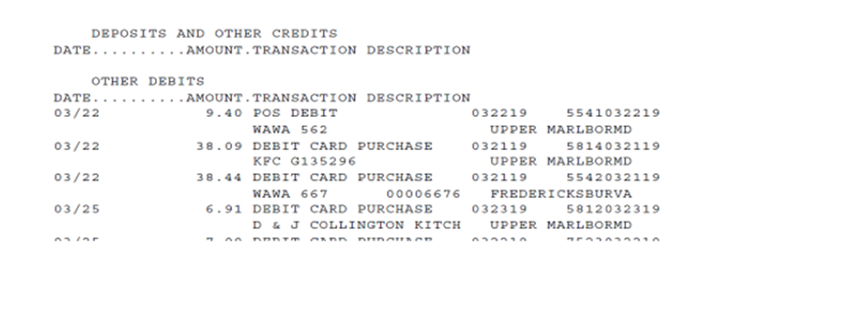

**2. Database Design Phases:**

Designing the family’s financial database is the most essential part of database development. A database design methodology is a structured approach that uses processes, procedures, techniques, tools, and documentation. Table 1 is the phrase approach containing the steps I used as a guide through the appropriate stages.

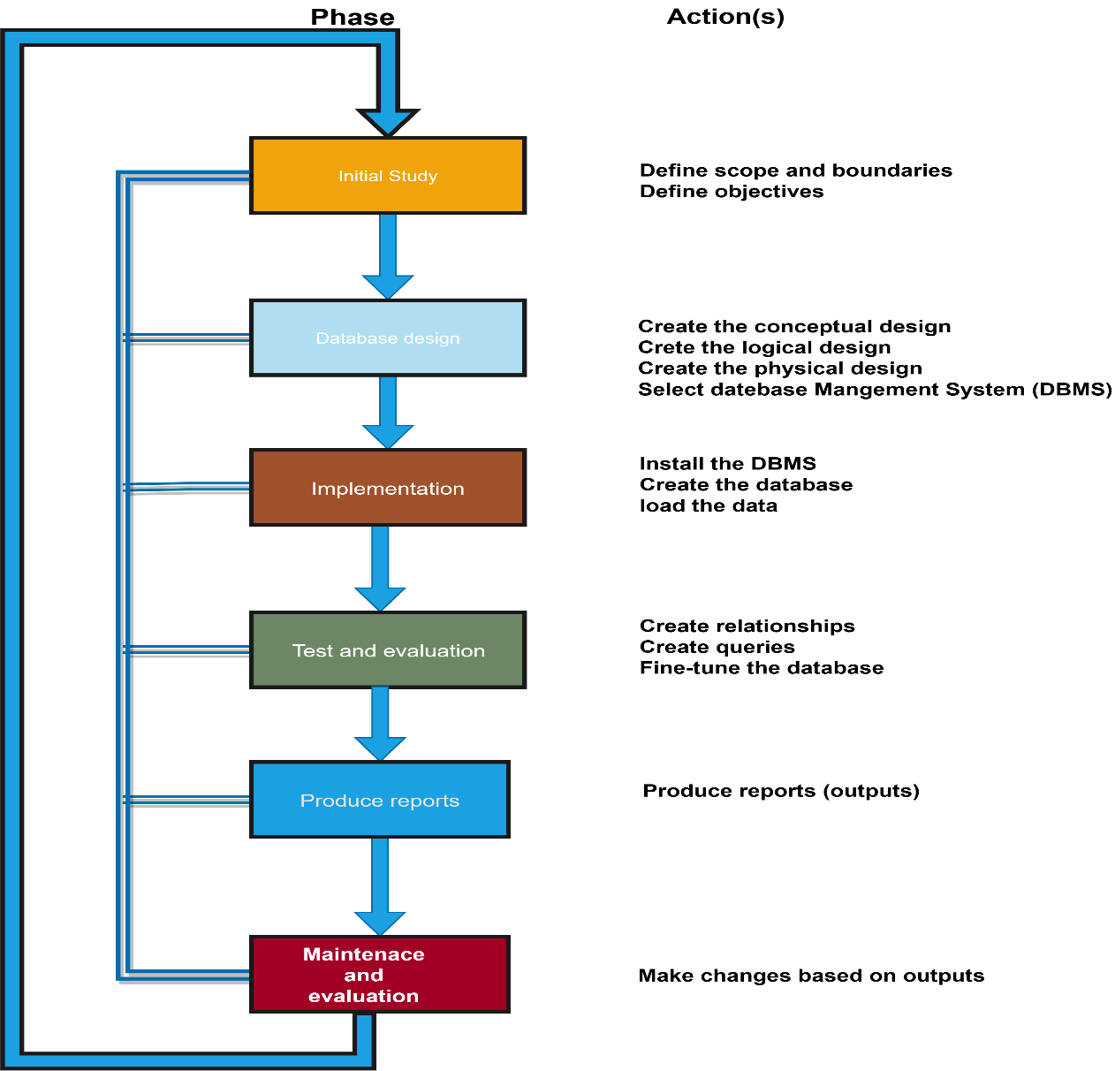

**Table 1 Design Phase**

**2.1 Constraints**

* Primary Key & Unique Constraints – enforce uniqueness of rows in a table
* Foreign Key Constraints – enforce Referential Integrity (“lookup” values)
* Data Types – enforce proper data type values (date, number, string, etc.)
* Nullability Constraints – determine whether a value is mandatory or not
* Cardinality Constraints – specifies then number of instances one entity can or must be associated with another

**2.2 Dependencies**

* Functional Dependency - a constraint between two attributes in which the value of one attribute is determined by the value of another attribute
* Partial Dependency - occurs when a non-prime attribute is functionally dependent on part of a candidate key.
* Multivalued dependency - occurs when there are more than one **independent** multivalued attributes in a table

**2.3** **Relationships between tables***:*

**Account type (**account number, **K) 1-M** **UserID (**account number, **FK)**

**UserID (**account number, **PK) 1-M** **Account Statement (**account number, **FK)**

**Transaction type (**transaction type, **PK) 1 -M Account Statement (**transaction type, **FK)**

**2.4 Tables (Entity and Attributes)**

Account (**Account Number, **Account type)

Users (UserID, **Account Number, User Name, User Address, User email address, User **Account type)

Account Bank Statement (**Account number, PayeeId, Payee, ** transaction type, amount, transaction date)

Transactions (**transaction type)

**Note**: ** Primary Keys and Foreign Keys

**2.6** **Conceptual Model**

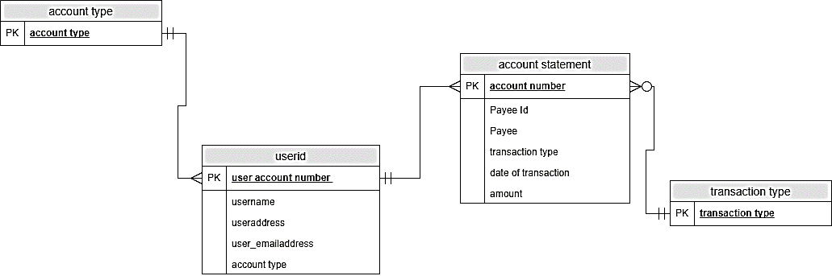

**2.7** **Normalized Logical Model**

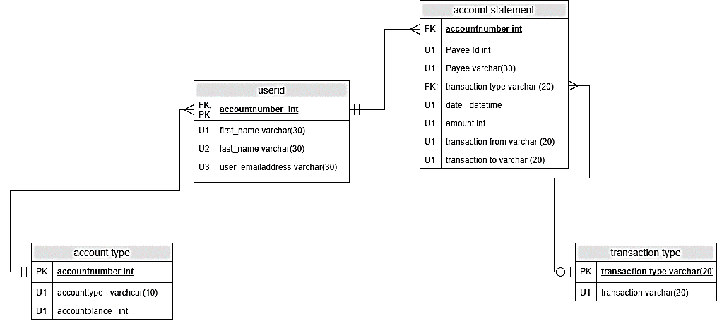

**Revised Logical Model**

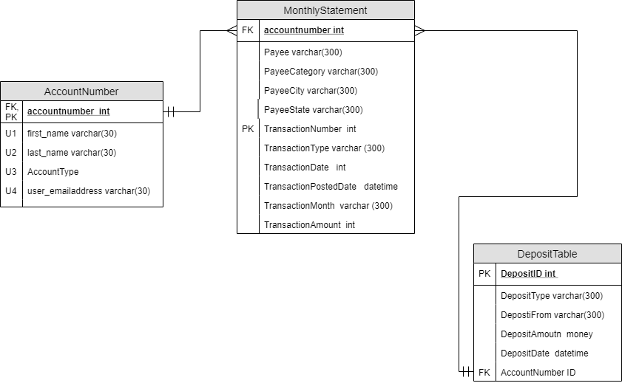

**2.8 Physical Model**

--Creating Tables for Personal Finance Database

CREATE TABLE AccountNumber

(

AccountNumberID bigint identity primary key,

AccountType varchar(300) NOT NULL unique,

AccountOwnerFirstName varchar(300) NOT NULL,

AccountOwnerLasttName varchar(300) NOT NULL,

AccountOwnerEmailAddress varchar(300) NOT NULL,

CONSTRAINT U1_AccountNumber UNIQUE (AccountType)

)

CREATE TABLE DepositTable (

DepositID bigint identity primary key,

DepositType varchar(300) NULL,

DepositFrom varchar(300) NULL,

DepositAmount Money NULL,

DepositDate Datetime NULL,

AccountNumberID bigint,

CONSTRAINT FK_DepositTable FOREIGN KEY (AccountNumberID) REFERENCES AccountNumber(AccountNumberID)

)

CREATE TABLE MonthlyStatement (

TransactionNumber bigint identity primary key,

TransactionType varchar(300) NULL ,

TransactionDate bigint NULL,

TransactionPostedDate datetime NULL,

TransactionMonth varchar (300) NULL,

TransactionAmount bigint NULL,

Payee varchar(300) NULL,

PayeeCategory varchar(300) NULL,

PayeeCity varchar(300) NULL,

PayeeState varchar(300) NULL,

AccountNumberID bigint,

CONSTRAINT FK_MonthlyStatement FOREIGN KEY (AccountNumberID) REFERENCES AccountNumber(AccountNumberID)

)

**3. Implementation: Using SQL Server Import and Export Wizard**

The execution was successful

- Initializing Data Flow Task (Success)

- Initializing Connections (Success)

- Setting SQL Command (Success)

- Setting Source Connection (Success)

- Setting Destination Connection (Success)

- Validating (Success)

Messages

* Warning 0x80049304: Data Flow Task 1: Warning: Could not open global shared memory to communicate with performance DLL; data flow performance counters are not available. To resolve, run this package as an administrator, or on the system's console.

(SQL Server Import and Export Wizard)

- Prepare for Execute (Success)

- Pre-execute (Success)

- Executing (Success)

Messages

* Information 0x402090df: Data Flow Task 1: The final commit for the data insertion in "Destination 2 - MonthlyStatement$" has started.

(SQL Server Import and Export Wizard)

* Information 0x402090df: Data Flow Task 1: The final commit for the data insertion in "Destination 1 - DepositTable$" has started.

(SQL Server Import and Export Wizard)

* Information 0x402090e0: Data Flow Task 1: The final commit for the data insertion in "Destination 1 - DepositTable$" has ended.

(SQL Server Import and Export Wizard)

* Information 0x402090e0: Data Flow Task 1: The final commit for the data insertion in "Destination 2 - MonthlyStatement$" has ended.

(SQL Server Import and Export Wizard)

- Copying to [dbo].[DepositTable$] (Success)

* 122 rows transferred

- Copying to [dbo].[MonthlyStatement$] (Success)

* 505 rows transferred

- Post-execute (Success)

(SQL Server Import and Export Wizard)

* Information 0x4004300b: Data Flow Task 1: "Destination 1 - DepositTable$" wrote 122 rows.

(SQL Server Import and Export Wizard)

* Information 0x4004300b: Data Flow Task 1: "Destination 2 - MonthlyStatement$" wrote 505 rows.

(SQL Server Import and Export Wizard)

-- Load Data in Personal Finance Database Tables

SET IDENTITY_INSERT dbo.AccountNumber ON

INSERT INTO AccountNumber (AccountNumberID, AccountType, AccountOwnerFirstName, AccountOwnerLasttName, AccountOwnerEmailAddress)

VALUES (5638, 'CHECKING','GILBERT','GUYAH','gilbertguyah@gmail.com');

SET IDENTITY_INSERT dbo.AccountNumber OFF

SET IDENTITY_INSERT dbo.DepositTable ON

INSERT INTO DepositTable (DepositID, DepositType, DepositFrom, DepositAmount,DepositDate,AccountNumberID)

SELECT DepositID, DepositType, DepositFrom, DepositAmount,DepositDate, AccountNumberID FROM DepositTable$

SET IDENTITY_INSERT dbo.DepositTable OFF

SET IDENTITY_INSERT dbo.MonthlyStatement ON

SELECT TransactionNumber, TransactionType, TransactionDate, TransactionPostedDate, TransactionMonth, TransactionAmount, Payee, PayeeCategory, PayeeCity,PayeeState, AccountNumberID FROM MonthlyStatement$

SET IDENTITY_INSERT dbo.MonthlyStatement OFF

**4. Pilot Test and Evaluate**

SELECT

MonthlyStatement.TransactionMonth,

MonthlyStatement.PayeeCategory,

SUM(TransactionAmount) as Purchase

FROM MonthlyStatement

WHERE TransactionMonth = 'July'

GROUP BY TransactionMonth,PayeeCategory

ORDER BY TransactionMonth DESC;

**Test Result:**

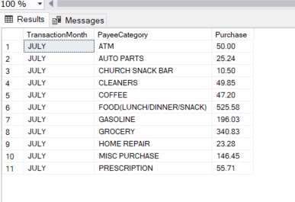

-- Creating a Graphical User Interface (GUI) – MicroSoft Access

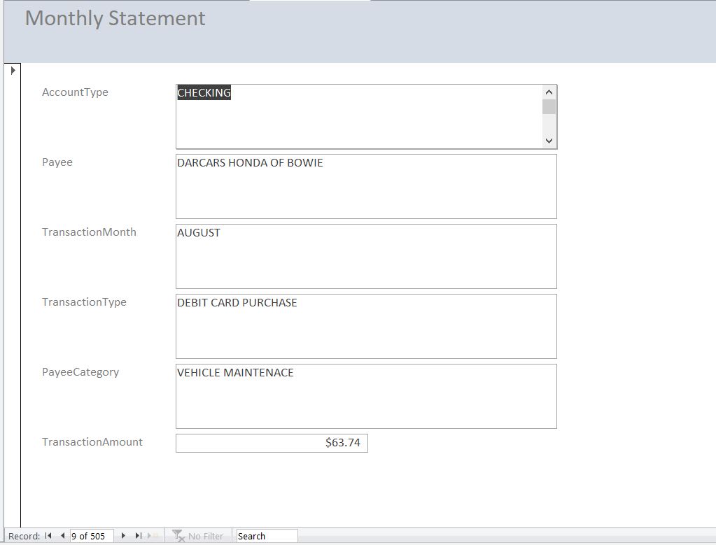

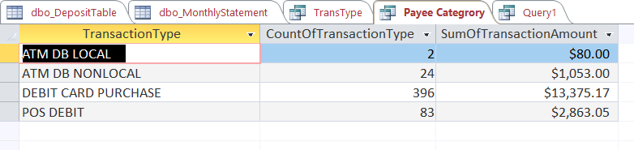

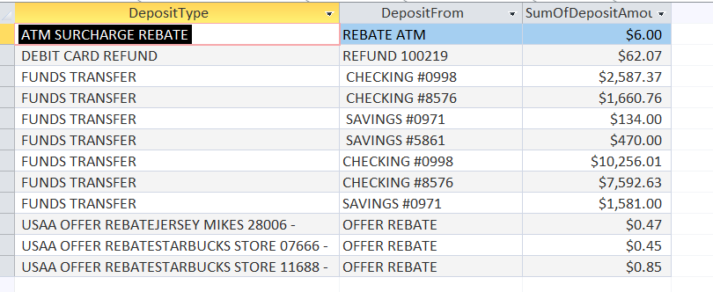

**5. Output**

What is the dollar amount per Payee?

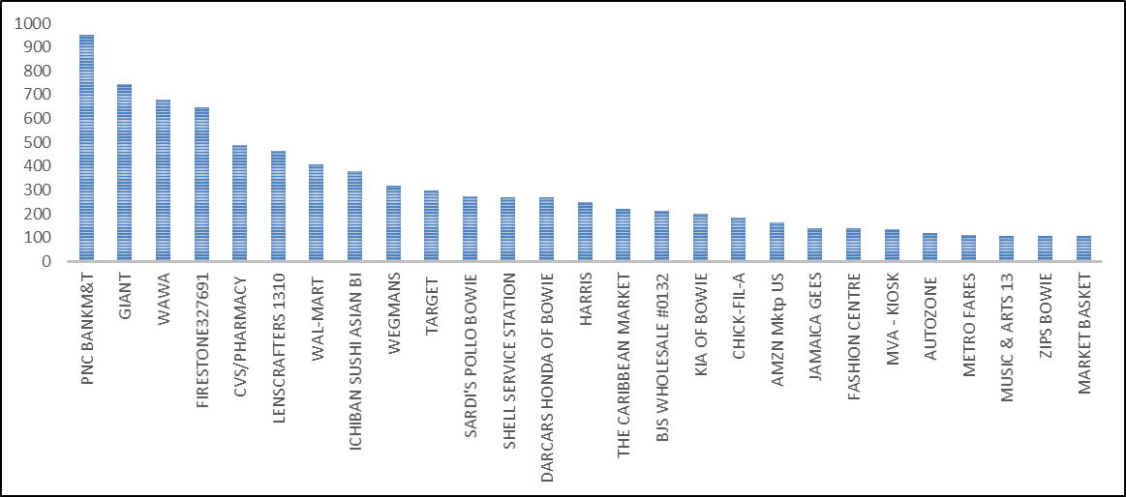

Which month I spend the most and on what of Transaction?

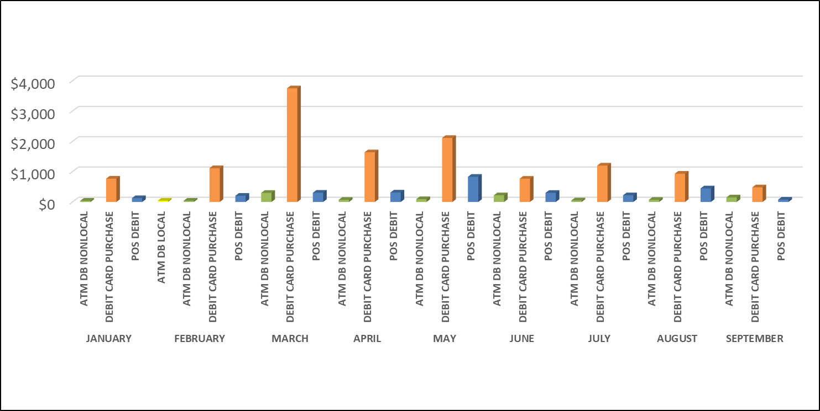

How many times of month do I transfer funds from my other accounts and how much $$$?



Where can I look for cost savings or avoidance?

FOOD (LUNCH/DINNER/SNACK) 3316.42

GASOLINE 1883.15

MISC PURCHASE 1761.58

ATM 1008.35

Looking the highest 4 spending categories, I believe cost saving and avoidance can be obtained by change my spending habits. i.e. limit the amount of time the family eat out at a restaurant, bring lunch to work instead of buying, limit the miscellaneous purchase and ATM withdrawal.

**Reflection**

Throughout this project, I learned that a properly designed database provides access to accurate data and information. The appropriate design is essential in achieving a working database; secondly, investing the time required to learn the principles of good design makes sense. I learned how to decide what information needed and input into the appropriate tables and columns and how those tables will relate to each other. However, at first, I was overzealous with my concept, looking at the 24-month timeline to extract data from 2018 and 2019 bank statements. I soon realized that converting and cleaning the data would take more time than allotted for this project. Also, I had to change tables, data types, and relationships. I believe working with data in various forms, creating a data model using Excel power query, and building charts & graphs made me a little overconfident when attempting this project. I had to reevaluate and take a crawl-walk-run approach of taking each lab as a building block.

This course provided the adequate tools needed to create a usable/meaningful database. The labs were a great source of practical information; each lab is a building block for the other. I would have liked to spend more time learning SQL; However, Lab 10, Creating a Graphical User Interface (GUI) using Microsoft Access as front end made it easier to connect to the tables within my database, create views, forms and sub-forms, reports, and export files to Excel. Connecting my database to R Studio was not as easy as I would have liked. I eventually exported my file to Excel, then imported the datasets to Rcmdr a GUI for R but eventually used Excel charts and graph to visualized my data. Overall, this project gave me insight into the following: My Personal finance, how to create a database, clean data, create a logical and conceptual model, download/connect to SQL Server, create a database with tables and constraints, insert data, modify the data, connect to an external source for visualization.

**Glossary of Acronyms**

**Char** Character

**Varchar** Variable Character

**Int** Integer

**U1** Unique Character

**Datetime** Date Time group

**FK** Foreign Key (An attribute or combination of attributes that uniquely identifies each row in a relation)

**PK**  Primary Key (An attribute in a relation that serves as the primary key of another relation in the same database***)***

**Montery** Currency

**1:1** One-to-one

**1:M One-to-Many**

**M:N** **Many-to-Many**

**M:1** **Many-to-one**

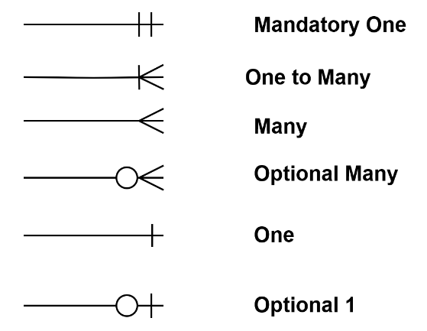

**Glossary of Terms**

**Attributes** A property or characteristics of an entity or relationship type that is of interest to the organization or user

**Constraint** A rule that cannot be violate by the database users

**Composite key** A primary key that consist of more than one attribute

**Data Model** A graphical system is used to capture the nature and relationship among data

**Entity** A person, place, an object, an event or concept in the user environment about which the organization wishes to maintain data

**Entity type** A collection of entities that share common properties or characteristics

**Relationship**

**Entity Type**

**Relationship** A meaningful association between or among entity types

**One-to-one (1:1) -** Each record in Table A can have only one matching record in Table B, and each record in Table B can have only one matching record in Table A. A one-to-one relationship is created if both related fields are primary keys or have unique indexes.

**One-to-many (1:M) -** Is the most common type of relationship and it is used to relate one record in a table with many records in another table. This kind of relationship is created if only one of the related fields is a primary key or has a unique index.

**Many-to-one (M:1)** - Is used to relate many records in a table with only one (single) record in another table. It is often called the lookup table relationship. Normally, this kind of relationship is not based on a primary key field in either table

**Many-to-many (M:M) -** Is used to relate many records in a table with many records in another table. A record (parent) in Table A can have many matching records (children) in Table B, and a record (child) in Table B can have many matching records (parents) in Table A. It is the hardest relationship to understand and it is not corrected

**Reference(s)**

Hoffer, J.A, Ramesh, V., & Topi, J. (2016). Modern database management (12th ed.). New York: Pearson

Watt, A. Chapter-13-database-development-process. Retrieved 24 October 2019. https://opentextbc.ca/dbdesign01/chapter/chapter-13-database-development-pocess